**Program 7: Digital Clock Using PHP Sooraj M Singh – 1CR18IS151**

**Write a PHP program to display a digital clock that displays the current time of the server.**

**Program:**

<head>

<style>

body {

font-family: Arial, Helvetica, sans-serif;

background-color: <?php echo date("#His");?>;

display: flex;

align-items: center;

justify-content: center;

}

.clock {

color: white;

font-size: 70px;

font-style: italic;

}

.color {

position: absolute;

bottom: 0;

left: 0;

padding: 10px;

color: white;

font-size: 20px;

font-style: italic;

}

</style>

<meta http-equiv="refresh" content="1">

<?php date_default_timezone_set("Asia/Kolkata"); ?>

<p class="clock"><?php echo date("H:i:s");?></p>

<p class="color">Color: <?php echo date("#His");?></p>

</head>

**Program Screenshot:**

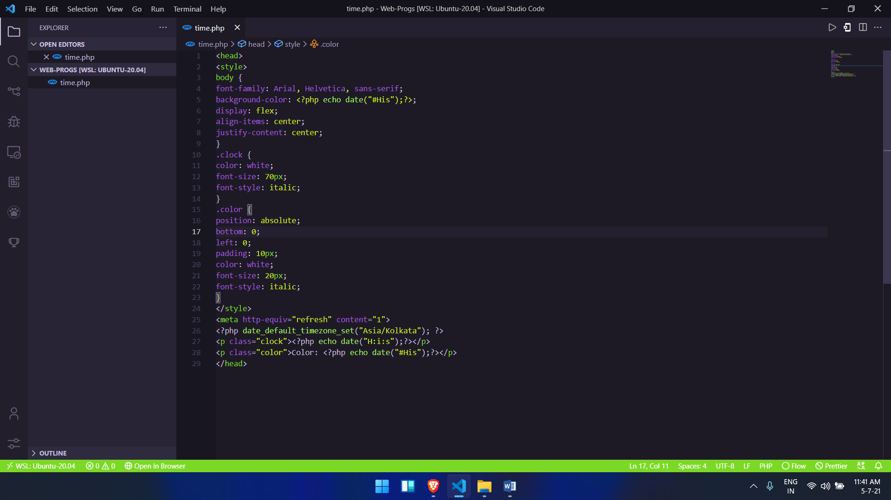

**Output Screenshots:**

